1

1. Abstract
EmpathI is a digital emergency response and donation coordination platform designed to improve the effectiveness of humanitarian assistance during large-scale crises such as natural disasters, pandemics, and public health emergencies. Unlike conventional crowdfunding systems that rely on passive visibility and popularity, EmpathI adopts an active, urgency-driven approach to ensure that critical needs receive timely attention. The platform enhances user-created campaigns using artificial intelligence, prioritizes cases based on urgency, and introduces micro-emergency tickets with countdown timers to address time-sensitive situations efficiently.
To ensure trust, transparency, and rapid coordination, EmpathI integrates community-based and on-ground verification mechanisms along with transparent donation tracking and proof-of-resolution reporting. During declared emergencies, an Emergency Mode is activated to streamline response efforts and enable rapid reallocation of emergency funds. The platform also features a Smart Resource Matching and Response System that connects urgent requests with nearby available resources, supporting both monetary and physical aid such as food, medicine, transport, and shelter. Through these features, EmpathI provides a structured, reliable, and real-time digital infrastructure for effective emergency response and relief coordination.
2. Background & Research Study
Existing literature and real-world observations reveal that charitable giving during crises is heavily influenced by emotional appeal, social sharing, and perceived trustworthiness rather than objective urgency. Key research findings include:
- Campaign visibility on digital platforms is driven by narrative quality and social reach rather than severity of need.
- Marginalized or digitally less-connected individuals are systematically disadvantaged in popularity-driven systems.
- Donor trust decreases when verification processes are opaque or delayed.
Research in disaster response and crisis management emphasizes several critical requirements:
- Timely, real-time information sharing during emergencies
- Decentralized and scalable verification mechanisms
- Rapid allocation of financial and physical resources
- Feedback loops to confirm resolution and impact
During the COVID-19 pandemic, grassroots efforts emerged on social media to crowdsource oxygen, hospital beds, and medicines. While impactful, these efforts suffered from:
- Fragmentation across platforms
- High risk of misinformation and fraud
- Lack of structured coordination
- Absence of long-term accountability
Technological studies further indicate that:
- Artificial intelligence can enhance clarity, reduce ambiguity, and highlight urgency in user-generated content.
- Urgency-based prioritization algorithms can outperform popularity-based ranking in time-critical scenarios.
- Blockchain-inspired ledgers provide tamper-proof audit trails without exposing sensitive data.
EmpathI synthesizes these insights by combining AI-driven campaign enhancement, urgency-based ranking, community verification, and immutable audit records into a single operational emergency-response workflow.
3. Problem Statement
During large-scale humanitarian emergencies such as natural disasters, pandemics, and public health crises, timely and efficient distribution of aid is critical. Existing digital crowdfunding platforms primarily operate as passive systems that depend on popularity, social reach, and user engagement to allocate attention and resources. As a result, urgent cases without strong online visibility often experience delays or receive insufficient support, leading to inefficient resource utilization and, in severe situations, loss of life.
Additionally, current platforms lack integrated mechanisms for real-time urgency assessment, verification of needs, and coordination of non-monetary resources. The absence of structured verification increases the risk of misinformation and fraudulent campaigns, while limited transparency reduces donor trust. Furthermore, the inability to rapidly reallocate funds or coordinate physical resources such as medical supplies, transport, and shelter restricts effective emergency response.
There is also no unified system to support direct coordination between individuals in need and nearby helpers or suppliers. Communication is often scattered across external platforms, causing delays and information loss. Emergency response efforts remain fragmented due to the lack of centralized oversight. These limitations reduce accountability and slow down resolution of critical cases. Hence, a robust, urgency-driven, and transparent digital emergency coordination system is required.
4. Objectives of the System
The primary objective of EmpathI is to develop a digital emergency response and donation coordination platform that improves the efficiency, transparency, and reliability of humanitarian aid delivery during large-scale crises. The scope of the system includes support for individuals, volunteers, donors, non-governmental organizations, and emergency responders by enabling structured coordination of both financial and physical resources. By shifting from a popularity-driven crowdfunding model to an urgency-based response framework, EmpathI seeks to ensure that time-critical needs receive immediate and appropriate attention.
The specific objectives within the defined scope of the system are as follows:
- To prioritize emergency cases based on urgency rather than popularity or social reach.
- To enable real-time coordination of donations and emergency assistance during crises.
- To enhance clarity and effectiveness of emergency campaigns using artificial intelligence.
- To verify emergency requests and resolutions through community-based and on-ground mechanisms.
- To support rapid allocation and reallocation of emergency funds for time-sensitive needs.
- To coordinate both monetary and physical resources, including food, medicine, transport, and shelter.
- To provide a Smart Resource Matching and Response System for efficient connection between needs and available resources.
- To ensure transparency through donation tracking and proof-of-resolution reporting.
- To enable centralized response through Emergency Mode activation during large-scale emergencies.
The scope of EmpathI extends across multiple stages of emergency response, including need identification, verification, prioritization, resource allocation, and resolution reporting. The platform supports the creation and enhancement of emergency campaigns using artificial intelligence to clearly communicate urgency and impact. It incorporates community-based and on-ground verification mechanisms to validate requests and outcomes, while enabling rapid allocation and reallocation of emergency funds during declared crises. Additionally, the scope includes coordination of essential physical resources such as food, medicine, transport, and shelter through a Smart Resource Matching and Response System.
5. Proposed System Overview

A. Block-Wise System Components
- User Interface Module
  - Allows users, donors, volunteers, NGOs, and responders to interact with the system
  - Supports request creation, donations, and resource listing
- Emergency Request Management Module
  - Handles submission of emergency requests
  - Converts time-critical cases into micro-emergency tickets
- AI Campaign Enhancement Module
  - Improves clarity of emergency requests
  - Highlights urgency, required resources, and consequences
- Urgency Prioritization Engine
  - Ranks cases based on severity and time sensitivity
  - Ensures critical cases are handled first
- Verification Module
  - Community-based verification through user reports
  - On-ground verification by local volunteers
- Emergency Fund Management Module
  - Maintains pooled emergency funds
  - Supports rapid fund allocation and reallocation
- Smart Resource Matching & Response System
  - Matches urgent needs with nearby available resources
  - Coordinates delivery of physical aid
- Emergency Mode Controller
  - Activates centralized response during large-scale crises
  - Redirects system focus to survival-critical cases
- Transparency & Reporting Module
  - Tracks donations and resource usage
  - Generates proof-of-resolution reports
B. Key Functional Capabilities
- Urgency-based prioritization of emergency cases
- AI-enhanced communication of emergency needs
- Real-time coordination of monetary and physical resources
- Rapid response during declared emergencies
- Verified and transparent aid distribution

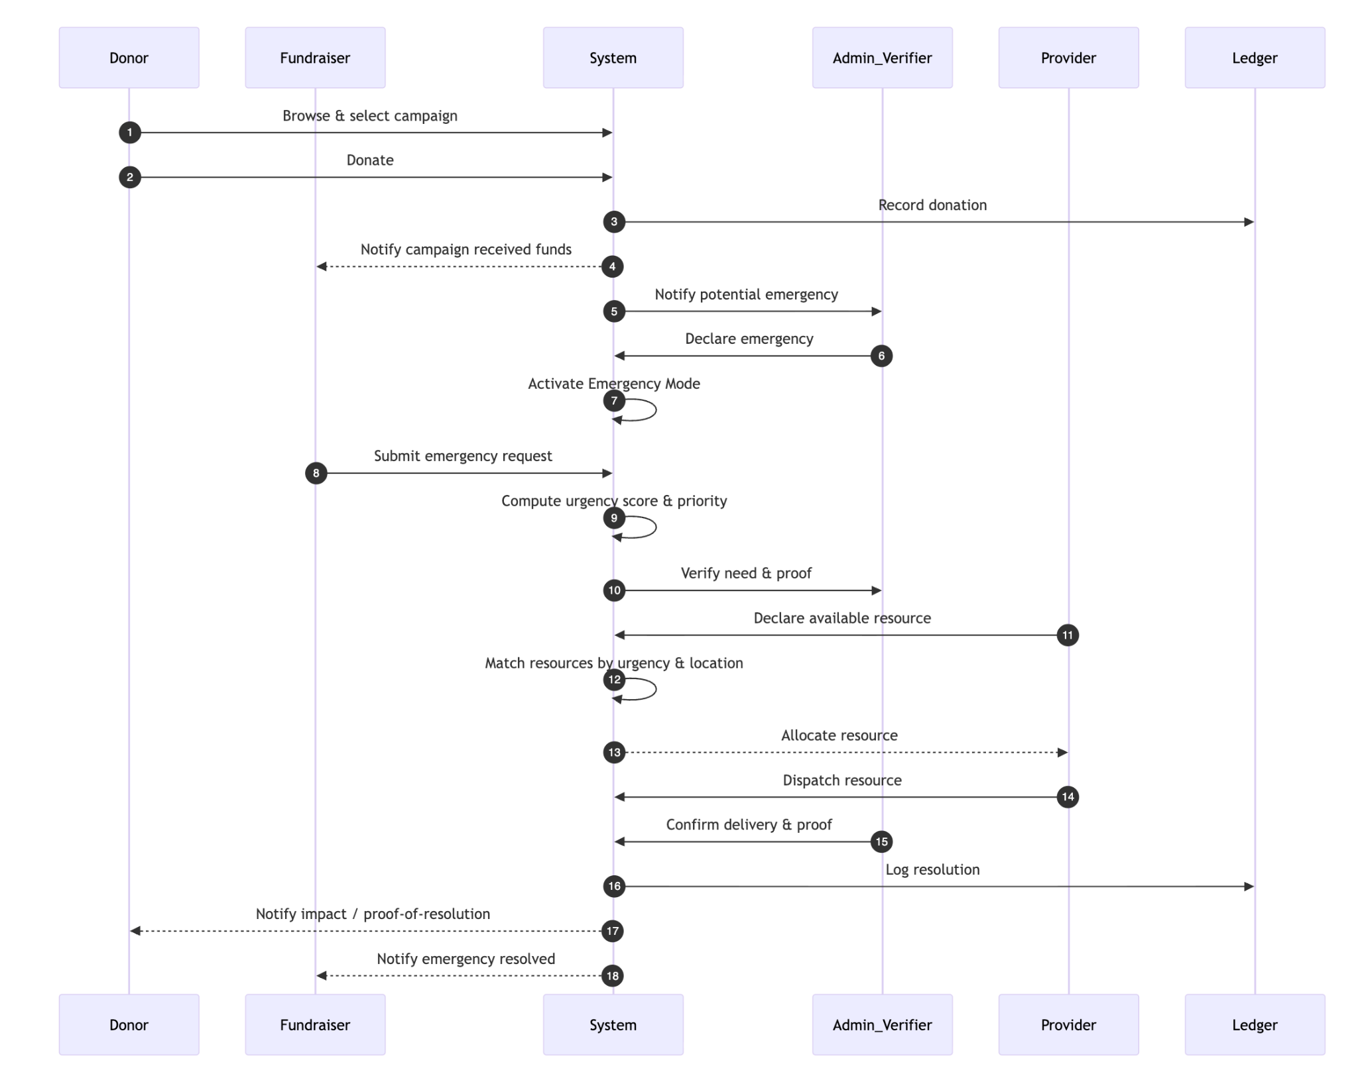
Figure 5.1 Sequence Diagram of basic functionalities of EmpathI

…… tbc

6. ETHICAL AND SOCIAL IMPACT

Ethical Impact
- Ensures fair and urgency-based distribution of aid instead of popularity-driven allocation.
- Reduces fraudulent and misleading requests through community-based and on-ground verification.
- Maintains transparency by tracking donations and providing proof-of-resolution reporting.
- Promotes accountability in emergency fund usage through verifiable audit mechanisms.
- Protects user privacy by securely handling sensitive emergency and donation-related data.
- Avoids over-reliance on automation by combining AI assistance with human verification.

Social Impact
- Improves speed and efficiency of emergency response during humanitarian crises.
- Enables coordination of both financial and physical resources such as food, medicine, and shelter.
- Encourages community participation and volunteer involvement in emergency relief efforts.
- Provides visibility to urgent cases that lack social reach or online influence.
- Strengthens public trust in digital donation and emergency response systems.
- Contributes to building a resilient, community-driven digital support infrastructure.

8. FEASIBILITY ANALYSIS
Feasibility analysis evaluates whether the proposed EmpathI system can be practically developed, deployed, and operated during real-world emergency situations. The analysis considers technical, economic, operational, legal, and social aspects of the system.

A. Technical Feasibility
- Built using mature technologies such as web platforms, cloud services, databases, and AI models.
- AI-based campaign enhancement and urgency prioritization are achievable using existing tools.
- Smart resource matching and verification modules rely on standard authentication mechanisms.
- Modular architecture supports scalability and integration with external services like maps and payment gateways.

B. Economic Feasibility
- Requires low initial investment due to cloud-based deployment.
- Uses open-source frameworks and APIs to reduce development cost.
- Operates on a pay-as-you-use model, lowering operational expenses.
- Long-term benefits outweigh maintenance and hosting costs.

C. Operational Feasibility
- Designed to be user-friendly for donors, volunteers, NGOs, and responders.
- Aligns with real emergency workflows such as request submission, verification, and aid delivery.
- Emergency Mode simplifies usage during crisis situations.
- Requires minimal training for users and volunteers.

D. Legal and Ethical Feasibility
- Ensures fairness through urgency-based prioritization.
- Prevents misuse through verification and transparent tracking.
- Protects user data using secure access and privacy controls.
- Acts as a coordination platform, reducing legal liability.

E. Social Feasibility
- Encourages community participation and volunteer engagement.
- Promotes inclusivity by prioritizing urgent cases over popularity.
- Builds trust between donors and beneficiaries.
- Contributes positively to emergency response and social welfare.
7. NOVELTY OF THE PROPOSED SYSTEM
- Coordination and Smart Matching of Physical Emergency Resources
The proposed system extends beyond monetary donations by enabling coordination of physical emergency resources such as food, medicine, oxygen, transport, and shelter. Emergency requests are automatically matched with nearby users, volunteers, or suppliers, ensuring rapid and targeted delivery of life-critical resources.
- Urgency-Based Prioritization with Micro-Emergency Tickets
Emergency cases are prioritized based on severity and time sensitivity rather than popularity. Each request is treated as a time-bound micro-emergency ticket with countdown indicators, emphasizing response deadlines and promoting prompt action.
- AI-Enhanced Campaign Descriptions and Transparent Resolution Tracking
Artificial intelligence improves the clarity and urgency of emergency descriptions, enabling faster understanding and response. Additionally, the system maintains transparent tracking of donations and provides proof-of-resolution after aid delivery, ensuring accountability.
- Rapid Emergency Fund Reallocation
The system allows quick redistribution of collected funds to higher-priority emergency cases, ensuring effective resource utilization in dynamic crisis situations.
- Community-Based and On-Ground Verification
Emergency requests and aid delivery are verified through trusted local volunteers, enhancing system reliability and trustworthiness.

7. CONCLUSION
The proposed system introduces a structured, urgency-driven approach to social and emergency response by integrating physical resource coordination, intelligent matching, and time-bound prioritization. By moving beyond popularity-based fundraising models, the platform ensures that critical emergencies receive timely attention and resources. Features such as Emergency Mode activation, rapid fund reallocation, and AI-enhanced request descriptions collectively improve response efficiency during both routine and large-scale crisis scenarios.
Furthermore, the incorporation of community-based verification and transparent donation tracking strengthens trust, accountability, and system reliability. By combining technological intelligence with human validation, the system offers a scalable and practical solution for equitable emergency assistance, making it suitable for real-world deployment in disaster management and social welfare ecosystems.

Tab 2
Perfect. Below is a complete, structured list of all user flows for EmpathI, written in a project / SRS / viva-friendly way.
I’ve grouped them by actor, and each flow is broken into clear step-by-step sequences so you can:
- Convert them into flowcharts
- Map them to use cases
- Defend them during evaluation

1. Donor User Flows

1.1 Donor Registration & Login Flow
Actors: Donor / Citizen
Flow:
- User opens EmpathI platform
- Selects Sign Up / Login
- Authenticates via email / phone / OAuth
- System validates credentials
- User is redirected to Donor Dashboard
Outcome: Authenticated donor profile created or accessed

1.2 Normal Donation Flow (Non-Emergency Mode)
Flow:
- Donor browses campaigns
- Selects a campaign
- Enters donation amount
- System displays emergency fractional contribution notice
- Donor confirms donation
- Payment processed via gateway
- System splits donation:
  - Primary campaign allocation
  - Fractional Emergency Piggy Bank allocation
- Donation receipt generated
- Donor dashboard updated
Outcome: Donation completed + emergency reserve updated

1.3 Donor Emergency Contribution Awareness Flow
Flow:
- Donor views dashboard
- Navigates to Emergency Preparedness
- Sees:
  - Total fractional contribution
  - Emergencies supported historically
- Optional adjustment or opt-out settings
- Changes saved
Outcome: Donor transparency and control

1.4 Emergency Mode Donation Flow
Flow:
- Emergency Mode activated
- Donor sees emergency-focused interface
- Urgent cases displayed by priority
- Donor selects:
  - Specific emergency case OR
  - Central emergency pool
- Confirms donation
- Funds allocated immediately
- Impact updates queued
Outcome: Rapid emergency support

1.5 Donor Impact & Proof-of-Resolution Flow
Flow:
- Donor receives notification
- Opens impact update
- Views:
  - Resource deployed
  - Location
  - Time
  - Verification proof
- Impact recorded in donor history
Outcome: Increased trust and retention

2. Campaign Creator / NGO Flows

2.1 Campaign Creation Flow (Normal Mode)
Actors: NGO / Individual Fundraiser
Flow:
- User logs in
- Selects Create Campaign
- Enters campaign details
- Uploads documents
- AI enhances description
- User reviews and submits
- Campaign enters verification queue
- Admin/AI verification completed
- Campaign goes live
Outcome: Approved fundraising campaign

2.2 Emergency Request / Micro-Ticket Flow
Flow:
- NGO logs in during Emergency Mode
- Selects Raise Emergency Request
- Chooses:
  - Resource type
  - Quantity
  - Location
  - Urgency
- Uploads proof
- Request submitted
- Enters verification and urgency scoring
- Approved request appears in priority feed
Outcome: Emergency need published and prioritized

2.3 Resource Receipt Confirmation Flow
Flow:
- NGO receives resource/funds
- Uploads delivery proof
- Confirms resolution
- Community verifiers validate
- Status marked resolved
Outcome: Case closed with audit trail

3. Community Verifier Flows

3.1 Verifier Onboarding Flow
Actors: Medical professionals, volunteers
Flow:
- User applies as verifier
- Submits credentials
- Admin reviews and approves
- Verifier role activated
Outcome: Trusted verifier added

3.2 Emergency Verification Flow
Flow:
- Verifier logs in
- Views assigned emergency requests
- Validates:
  - Documents
  - Location
  - Need severity
- Submits verification status
- Peer verification consensus applied
Outcome: Request verified or rejected

3.3 Proof-of-Resolution Verification Flow
Flow:
- Verifier receives resolution task
- Reviews geo-tagged evidence
- Confirms or disputes resolution
- Audit log updated
Outcome: Transparent closure confirmation

4. Admin Flows

4.1 Crisis Detection & Declaration Flow
Actors: Platform Admin
Flow:
- Admin reviews crisis signals
- Validates news and authority sources
- Declares crisis
- Sets geo-scope (city/state/national)
- Activates Emergency Mode
Outcome: Platform transitions to emergency state

4.2 Emergency Fund Unlock Flow
Flow:
- Crisis declared
- Emergency Piggy Bank status checked
- Admin approves unlock
- Funds released for allocation
- Unlock recorded in audit ledger
Outcome: Emergency funds available

4.3 Resource Allocation Oversight Flow
Flow:
- Admin views urgency-ranked requests
- Monitors allocation decisions
- Overrides if necessary
- Confirms fund/resource dispatch
Outcome: Controlled emergency deployment

5. Vendor / Clinic Flows

5.1 Vendor Registration & Validation
Actors: Clinics, suppliers, logistics
Flow:
- Vendor applies
- Submits business verification
- Admin approval
- Vendor added to resource pool
Outcome: Trusted vendor onboarded

5.2 Resource Fulfillment Flow
Flow:
- Vendor receives allocation request
- Confirms availability
- Dispatches resource
- Uploads dispatch proof
- Marks fulfilled
Outcome: Resource delivered

6. System-Level Automated Flows

6.1 Crisis Signal Ingestion Flow
Flow:
- System fetches news/alerts
- AI filters crisis relevance
- Flags potential emergencies
- Admin notified
Outcome: Early crisis detection

6.2 Urgency Scoring Flow
Flow:
- Emergency request created
- Parameters extracted
- Urgency score computed
- Request ranked dynamically
Outcome: Priority-based response

6.3 Emergency Fund Accumulation Flow
Flow:
- Donation received
- Fraction calculated
- Amount added to emergency fund
- Ledger updated
Outcome: Continuous preparedness

6.4 Audit & Transparency Flow
Flow:
- Every critical action hashed
- Entry added to audit ledger
- Public verification enabled
Outcome: Immutable accountability

7. Master User Flow Summary (One Slide)
Donate → Accumulate → Detect Crisis → Verify → Prioritize
→ Allocate → Deploy → Confirm → Audit → Report

If you want next (highly recommended)
- Convert this into Mermaid flowcharts
- Create Use Case Diagram
- Generate DFD Level 0 / Level 1
- Produce sequence diagrams for emergency activation
Just tell me which one you want next.

That’s an excellent addition, and it fits perfectly with EmpathI’s philosophy.
What you’re describing is not donation, it’s dynamic resource sharing — and that’s a clear novelty upgrade.
Below is a clean, formal extension you can add without breaking your existing design. I’ll give you:
- The concept definition
- Where it fits in EmpathI
- New user flows (step-by-step, report-ready)
- A short novelty justification you can reuse

Resource Sharing Based on Availability and Need

Concept Overview
EmpathI introduces a Resource Sharing and Rebalancing Mechanism that enables individuals, NGOs, clinics, hospitals, and vendors to share surplus physical resources (such as oxygen cylinders, medicines, beds, transport capacity, or food supplies) with entities experiencing shortages during emergencies.
Unlike traditional donation systems that rely primarily on monetary transfers, this mechanism treats physical resources as first-class entities within the platform and enables real-time redistribution based on availability, proximity, urgency, and perishability.
This system ensures that existing resources within a region are utilized optimally before procuring new supplies, thereby reducing response time and wastage.

Positioning Within EmpathI
This feature operates only during Emergency Mode and works alongside:
- Micro-Emergency Ticketing
- Urgency Scoring Engine
- Resource Mapping & Allocation Service
- Emergency Preparedness Piggy Bank
It complements monetary aid by enabling peer-to-peer and institution-to-institution resource sharing.

New Functional Module: Resource Exchange Layer

Core Capabilities
- Real-time declaration of available surplus resources
- Structured requests for needed resources
- Automated matching between availability and need
- Location-aware and urgency-aware prioritization
- Verification and proof-of-transfer tracking

New User Flows (Add These to Section “User Flows”)

8. Resource Availability Declaration Flow
Actors: Clinics, NGOs, Vendors, Individuals
Flow:
- User logs in during Emergency Mode
- Selects Declare Available Resource
- Specifies:
  - Resource type (oxygen, medicine, food, transport)
  - Quantity
  - Expiry/perishability (if applicable)
  - Location
  - Time window of availability
- Submits declaration
- System validates and lists resource in availability pool
Outcome: Resource becomes discoverable for matching

9. Resource Need Request Flow (Non-Monetary)
Actors: Hospitals, NGOs, Individuals
Flow:
- User selects Request Resource
- Enters:
  - Resource type
  - Quantity
  - Location
  - Urgency level
  - Proof (optional but preferred)
- Request submitted
- Enters urgency scoring and verification pipeline
Outcome: Verified resource need added to priority queue

10. Resource Matching & Recommendation Flow (System-Driven)
Actors: System (Automated)
Flow:
- System scans available resources
- Filters by:
  - Geographic proximity
  - Resource compatibility
  - Availability window
  - Perishability constraints
- Computes match score using:
  - Distance
  - Urgency
  - Resource scarcity
- Recommends optimal matches
- Notifies resource provider and requester
Outcome: Optimal resource-provider pair identified

11. Resource Transfer Confirmation Flow
Actors: Resource Provider & Receiver
Flow:
- Provider accepts sharing request
- Transfer initiated (pickup / delivery)
- Provider uploads dispatch confirmation
- Receiver uploads receipt confirmation
- Community verifier validates transfer
- Status marked as Resolved
Outcome: Resource successfully redistributed

12. Resource Rebalancing Flow (Advanced / System-Level)
Actors: System + Admin Oversight
Flow:
- System detects regional imbalance:
  - Excess supply in Region A
  - Shortage in Region B
- Admin approves inter-region transfer
- Logistics partners notified
- Funds from emergency pool cover transport if needed
- Transfer executed and logged
Outcome: System-level resource optimization

Data Model Additions (Minimal but Powerful)
Add these entities:
- ResourceAvailability
- ResourceRequest
- ResourceMatch
- ResourceTransfer
- TransferProof
These integrate cleanly with your existing schema.

Ethical & Safety Safeguards (Important for Evaluation)
- No forced sharing; providers opt-in
- Medical resource sharing restricted to verified entities
- Perishable goods prioritized by expiry
- Admin override for high-risk transfers

Short Novelty Statement (You will be asked this)
“EmpathI extends beyond donations by enabling real-time, location-aware resource sharing, ensuring that surplus supplies are dynamically reallocated to critical shortages before new procurement is initiated.”

One-Line System Summary Update
You can safely add this line to your overview:
In addition to fundraising, EmpathI supports urgency-based physical resource sharing, allowing surplus medical and essential supplies to be dynamically redistributed based on real-time availability and need.

What I recommend next (very useful)
- Update architecture diagram with a Resource Exchange Layer
- Add sequence diagram for resource sharing
- Write limitations & misuse prevention section
- Convert this into DFD Level 1
Tell me which one you want next and I’ll do it cleanly.

